HIRE IT – FOR ALL YOUR CAR HIRE NEEDS

We offer car hire with incredibly competitive prices. Come to us for all your car hire needs.

What we offer:
- Competitive prices
- Fully comprehensive insurance
- Breakdown services

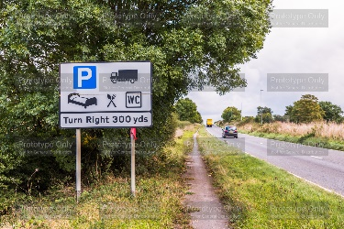
We have a range of cars available from Standard to Large SUVs. We are sure we will have one to suit your needs. You may be going on holiday or needing a car for work, whatever you want it for, we can help. Our cars all come with SAT NAV so regardless of your reason for hiring a car, you will never get lost. SAT NAV also provides you with the nearest petrol stations, restaurants, service stations and car parks so you always know where you can stop should you need to.

We have said we offer competitive prices for car hire and we pride ourselves on the fact that we can usually price match with other larger companies. We also offer discounts for new clients and this can be up to 20% off depending on the car you hire with us. We may have other offers available on the day you book so keep an eye on what is available. You can collect from your nearest office or you can request delivery to your home (or workplace) although this option has an additional fee.


Car Type | Transmission available | Fuel type available
STANDARD | Manual | Petrol
SMALL SUV | Manual | Petrol
LARGE SUV | Automatic | Electric

You can use the Enquiries link on the website or phone us to find out more.

